INSTALL JDK and MYSQL SERVER
ihvn@ihvn-Latitude-5400:~$ sudo apt-get update

ihvn@ihvn-Latitude-5400:~$ sudo apt-get install openjdk-8-jdk

ihvn@ihvn-Latitude-5400:~$ sudo apt-get install mysql-server
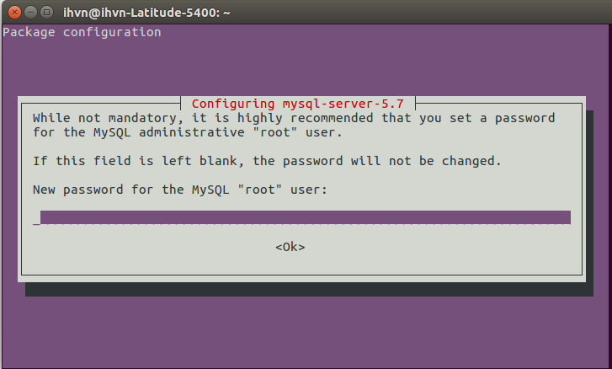

ihvn@ihvn-Latitude-5400:~$ sudo systemctl start mysql

ihvn@ihvn-Latitude-5400:~$ sudo systemctl enable mysql

skip next two steps

ihvn@ihvn-Latitude-5400:~$ mysql -u root -p // This is to start up your Mysql server

mysql> select User, Host authentication_string From mysql.user; // This should display table of users

INSTALL MYSQL WORK-BENCH

ihvn@ihvn-Latitude-5400:~$ sudo apt-get install mysql-workbench

Always use sudo -i to change to root
ihvn@ihvn-Latitude-5400:~$ sudo -i

TOMCAT INSTALLATION

root@ihvn-Latitude-5400:/tmp# cd /tmp

root@ihvn-Latitude-5400:/tmp# sudo groupadd tomcat

root@ihvn-Latitude-5400:/tmp# useradd -s /bin/false -g tomcat -d /opt/tomcat tomcat

root@ihvn-Latitude-5400:/tmp# cd /root

root@ihvn-Latitude-5400:~# mkdir /opt/tomcat

root@ihvn-Latitude-5400:~# cd /opt/tomcat

root@ihvn-Latitude-5400:~# cd ..
root@ihvn-Latitude-5400:/opt#
// Go to Tomcat official website to copy Tomcat 9 download link
step1 : https://downloads.apache.org/tomcat/tomcat-9/v9.0.39/bin/apache-tomcat-9.0.39.tar.gz

I downloaded the tomcat 9.0.39.tar.gz and pasted it in opt folder directly. I have updated the link above.
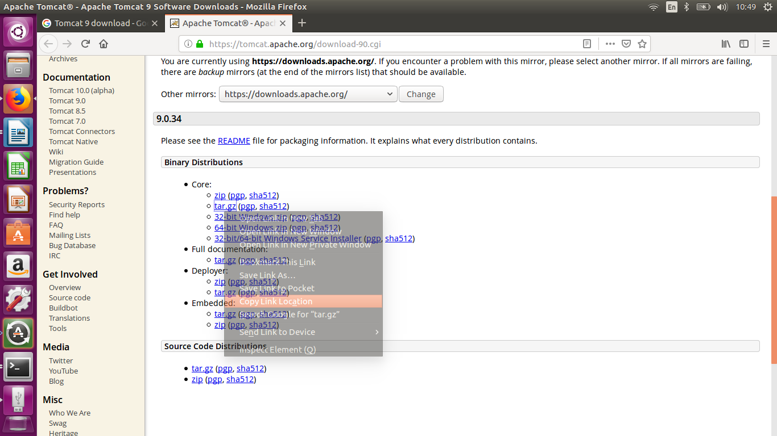

root@ihvn-Latitude-5400:/opt# wget <the link you copied from above step>

ihvn@ihvn-Latitude-5400:/opt$ ls // check files in the “/opt” folder to confirm tomcat 9 tar.gz is downloaded
apache-tomcat-9.0.34.tar.gz // this is the file you should see in your “/opt” folder

root@ihvn-Latitude-5400:/opt# sudo tar xzvf apache-tomcat-9.0.39.tar.gz -C /opt/tomcat --strip-components=1

root@ihvn-Latitude-5400:~# cd /opt/tomcat

root@ihvn-Latitude-5400:/opt/tomcat# sudo chgrp -R tomcat /opt/tomcat

root@ihvn-Latitude-5400:/opt/tomcat# sudo chmod -R g+r conf

root@ihvn-Latitude-5400:/opt/tomcat# sudo chmod g+x conf

root@ihvn-Latitude-5400:/opt/tomcat# sudo chown -R tomcat webapps/ work/ temp/ logs/

root@ihvn-Latitude-5400:/opt/tomcat# sudo update-java-alternatives -l

java-1.8.0-openjdk-amd64 1081 /usr/lib/jvm/java-1.8.0-openjdk-amd64 // this is how the output looks like, copy the Path and save somewhere.

root@ihvn-Latitude-5400:/opt/tomcat# sudo nano /etc/systemd/system/tomcat.service

<Copy the painted code below and paste in the window that pops up but change “/usr/lib/jvm/java-1.8.0-openjdk-amd64” with the Path displayed by your Machine in two steps above which you copied and saved>

[Unit]
Description=Apache Tomcat Web Application Container
After=network.target

[Service]
Type=forking

Environment=JAVA_HOME=/usr/lib/jvm/java-1.8.0-openjdk-amd64/jre
Environment=CATALINA_PID=/opt/tomcat/temp/tomcat.pid
Environment=CATALINA_HOME=/opt/tomcat
Environment=CATALINA_BASE=/opt/tomcat
Environment='CATALINA_OPTS=-Xms1024M -Xmx2048M -server -XX:+UseParallelGC'
Environment='JAVA_OPTS=-Djava.awt.headless=true -Djava.security.egd=file:/dev/./urandom'

ExecStart=/opt/tomcat/bin/startup.sh
ExecStop=/opt/tomcat/bin/shutdown.sh

User=tomcat
Group=tomcat
UMask=0007
RestartSec=10
Restart=always

[Install]
WantedBy=multi-user.target
DO CTRL O TO SAVE, HIT ENTER BUTTON
DO CTRL X TO EXIT.
USE UP ARROW TO REPEAT COMMAND,HIT ENTER TO SEE IF IT SAVED SUCCESSFULLY

root@ihvn-Latitude-5400:/opt/tomcat# sudo systemctl daemon-reload

root@ihvn-Latitude-5400:/opt/tomcat# sudo systemctl start tomcat

root@ihvn-Latitude-5400:/opt/tomcat# sudo systemctl status tomcat

Open a new terminal, type the below command

cd /opt/tomcat

root@ihvn-Latitude-5400:/opt/tomcat# sudo systemctl enable tomcat
<At this point your Tomcat should be up http://localhost:8080/ , without any admin account created yet>

DEPLOYMENT OF OPENMRS WAR FILE

root@ihvn-Latitude-5400:/opt# sudo apt install libgnome2-bin

root@ihvn-Latitude-5400:/opt# sudo systemctl restart tomcat

cd ..

root@ihvn-Latitude-5400:/opt# gnome-open tomcat
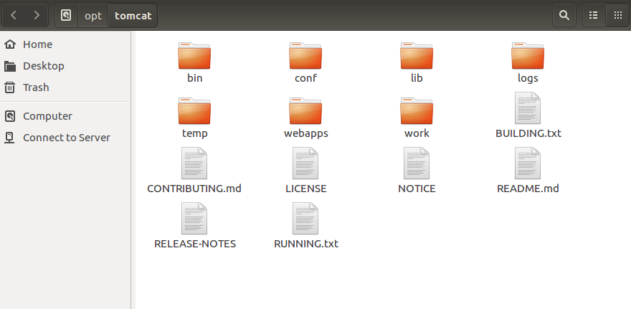

<Open the Conf Folder>
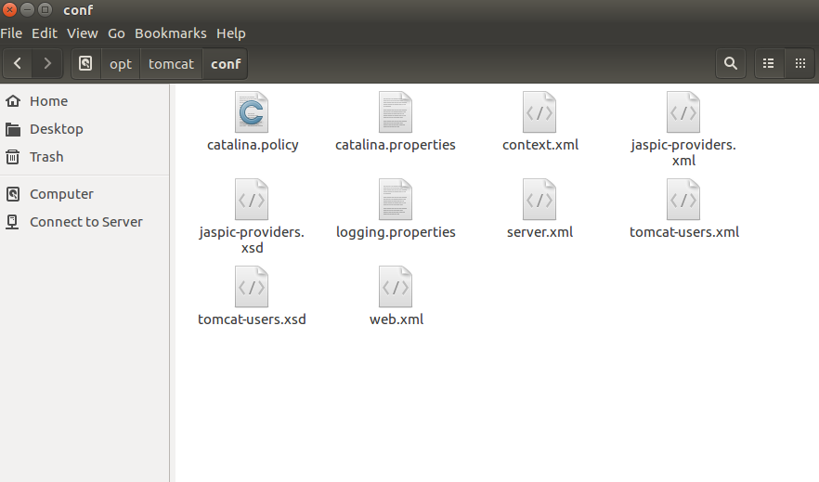

Open tomcat-users.xml and paste the roles below as shown picture below and Save
<role rolename="manager-gui"/>
<role rolename="admin-gui"/>
<role rolename="manager-jmx"/>
<role rolename="manager-status"/>

<user username="admin" password="Admin123" roles="admin-gui"/>
<user username="admin" password="Admin123" roles="manager-gui"/>
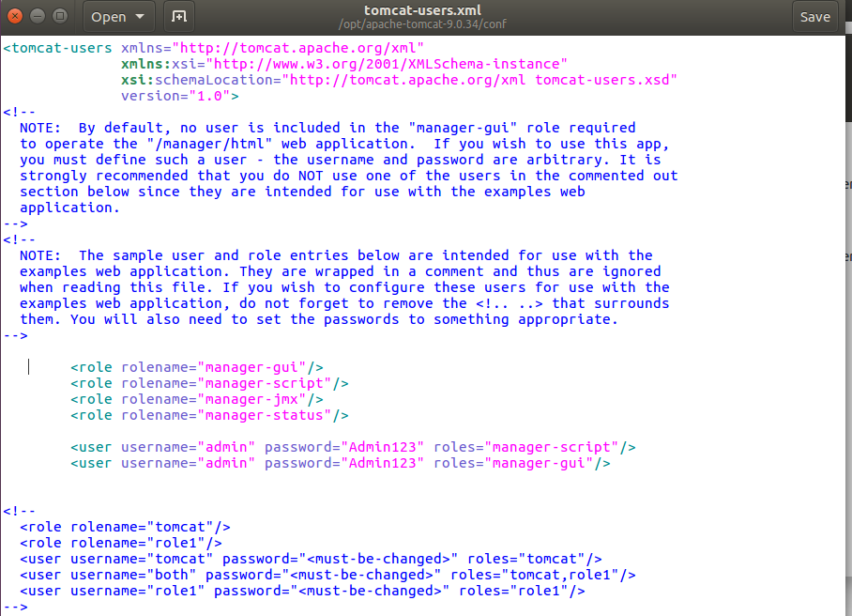
Open Server.xml and Change the Server port from 8080 to 8081 and Save
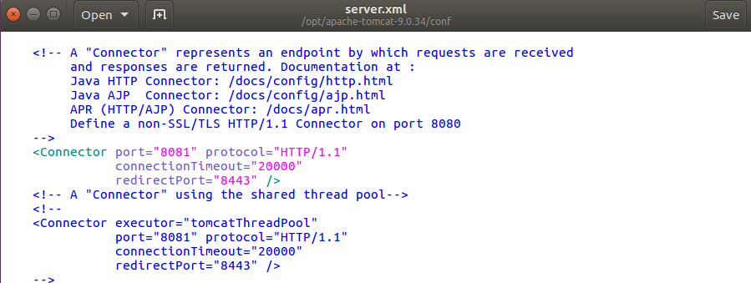
<Assign more memory to Java>
Open Tomcat folder (by clicking back arrow on the already opened folder)
open WebApp folder
manager
WEB-INF

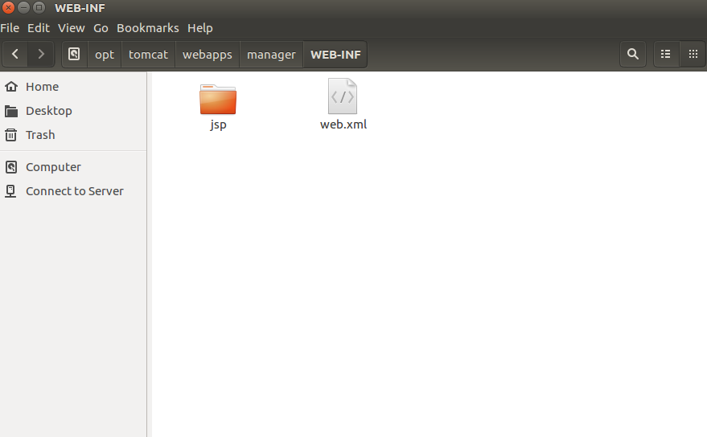

Open web.xml file in this folder (Remember this file is other folders)
Change Multipart-config from
<multipart-config>
<!-- 50MB max -->
<max-file-size>52428800</max-file-size>
<max-request-size>52428800</max-request-size>
<file-size-threshold>0</file-size-threshold>
</multipart-config>
To:
<multipart-config>
<!– 90MB max –>
<max-file-size>92428800</max-file-size>
<max-request-size>92428800</max-request-size>
<file-size-threshold>0</file-size-threshold>
</multipart-config>
Then SAVE
root@ihvn-Latitude-5400:/opt/tomcat# sudo mkdir /var/lib/OpenMRS

root@ihvn-Latitude-5400:/opt/tomcat# sudo chown -R tomcat /var/lib/OpenMRS

<Its recommended to restart the System at this point>

Upload War file for Deployment
GO TO localhost:8081/
LOGIN WITH USN admin, PWD Admin123
SCROLL TO WAR File To Deploy
CLICK BROWSE AND ATTACHE YOUR FILE FROM YOUR DESKTOP,THEN DEPLOY.
SCROLL BACK UP TO OPENMRS,RIGHT CLICK AND OPEN IN A NEW TAB
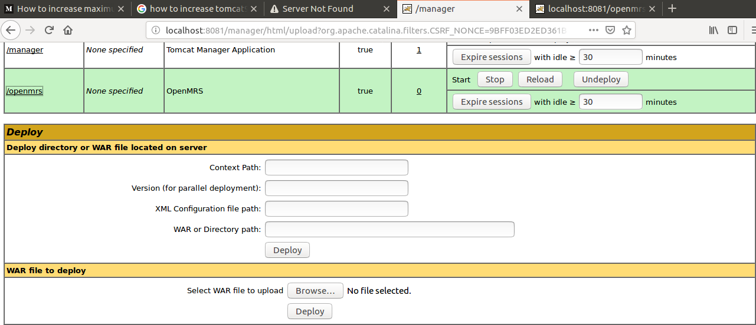
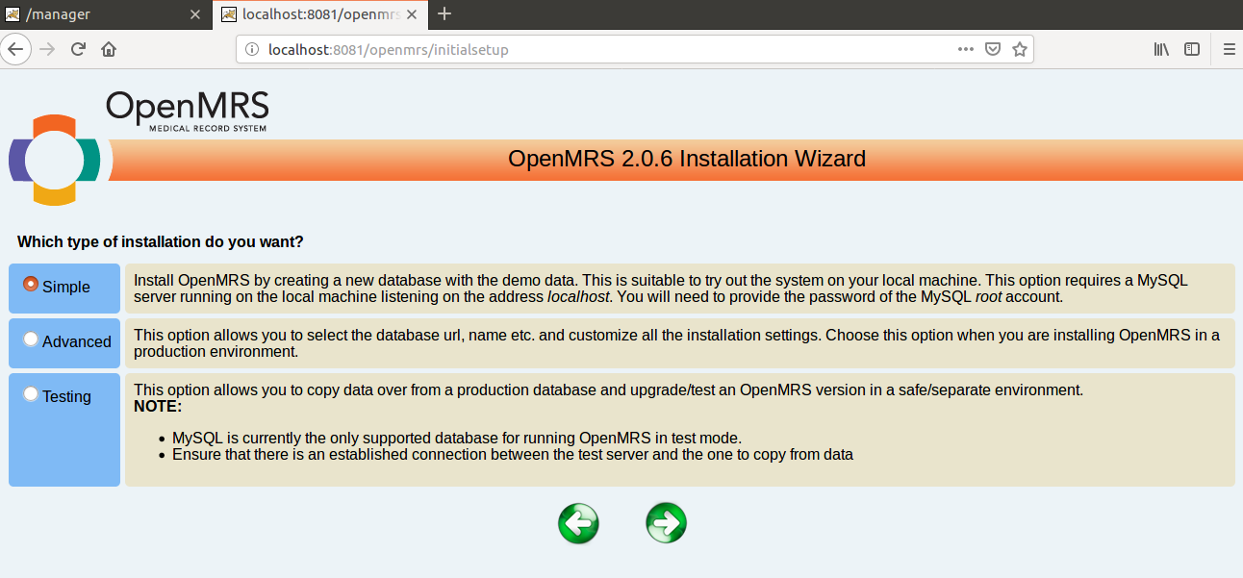

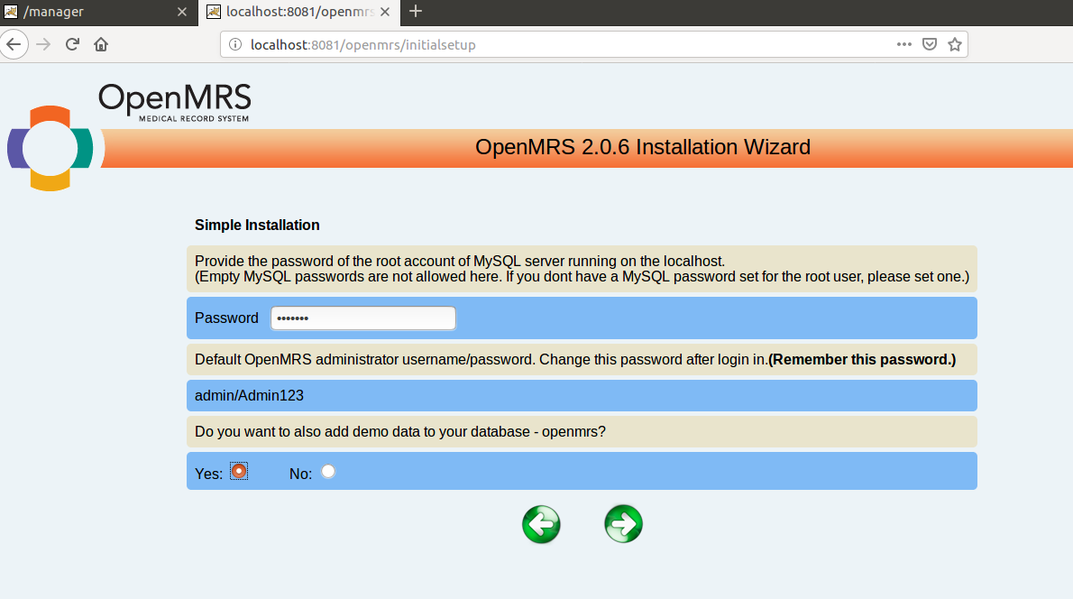

Copy and save the Installation Path “/var/lib/OpenMRS/openmrs-runtime.properties”
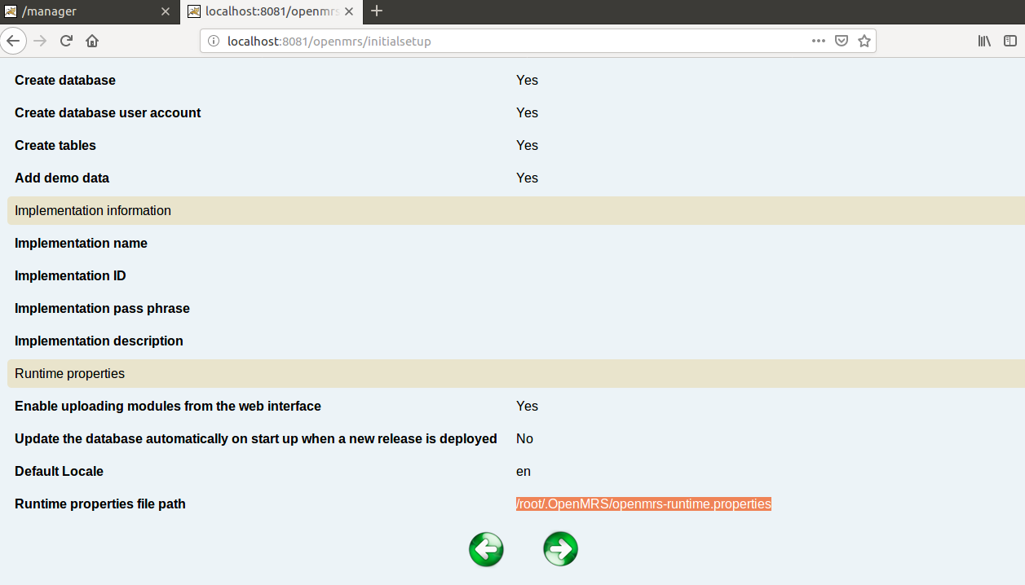

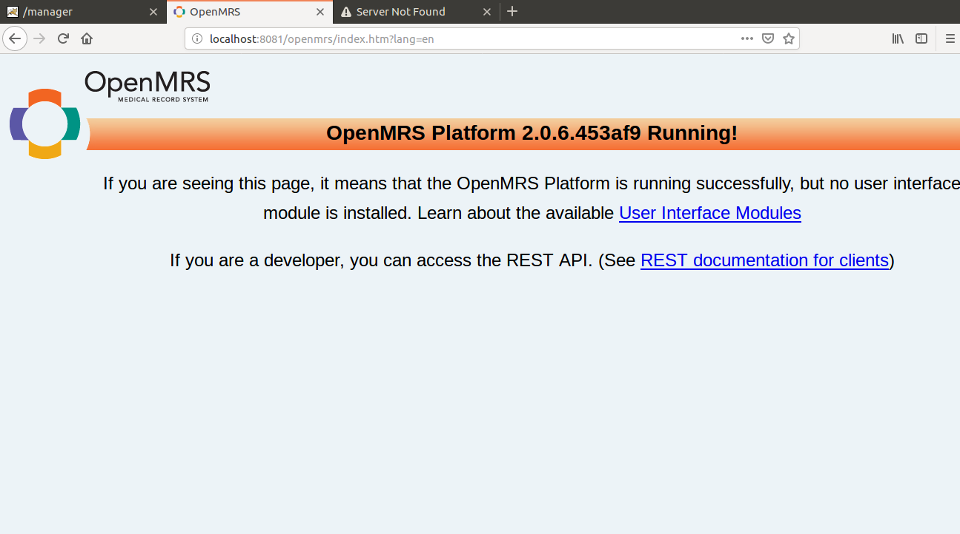
Installation completed

<Install the UI Omods>

root@ihvn-Latitude-5400:/opt/tomcat# cd /var/lib/OpenMRS

root@ihvn-Latitude-5400:/opt/tomcat# cd ..

root@ihvn-Latitude-5400:/opt# gnome-open OpenMRS // Open the Modules folder, copy and paste your Omods

PASTE LEGACY MODULE FIRST AND RUN YOUR SYSTEM. THEN PASTE THE REMAINING MODULES
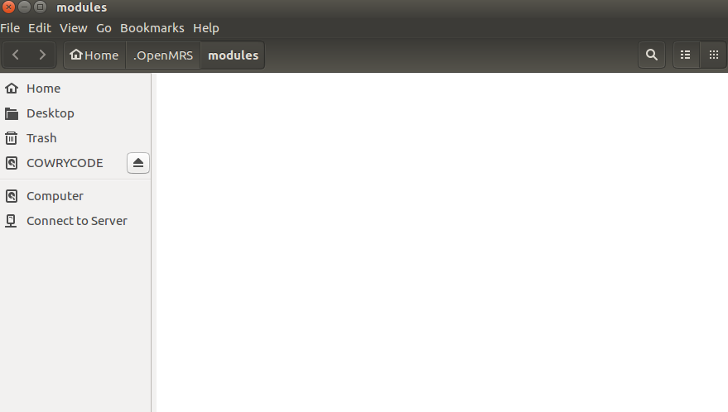

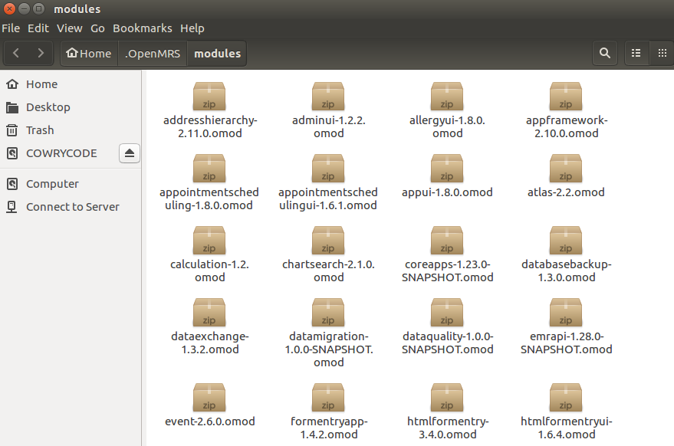
RESTART THE SYSTEM

SETUP SERVER TO RUN RADET

Run the “latest_function” patch using Navicate.

ihvn@ihvn-Latitude-5400:~$ sudo nano /etc/mysql/my.cnf // or use GUI, open my.cnf file from computer/etc/mysql/my.cnf

Copy and paste the code below at the bottom of the page then save.

[mysqld]
sql_mode="STRICT_TRANS_TABLES,NO_AUTO_CREATE_USER,NO_ENGINE_SUBSTITUTION"

ihvn@ihvn-Latitude-5400:~$ sudo service mysql restart // to restart the server.

root@ihvn-Latitude-5400:~/.OpenMRS# mysql -u root -p // then enter password

mysql> CREATE USER 'openmrs'@'localhost' IDENTIFIED BY 'root'; // this step assumes you don’t have a user named “openmrs” already
Query OK, 0 rows affected (0.02 sec)

mysql> SELECT User, Host, authentication_string From mysql.user ;

mysql> GRANT ALL PRIVILEGES ON openmrs.* TO openmrs@'localhost'; // Grant all privileges

mysql> SHOW GRANTS FOR 'openmrs'@'localhost';

